
TRIBHUVAN UNIVERSITY
INSTITUTE OF SCIENCE AND TECHNOLOGY

A Project Proposal On
RESUME-DRIVEN ADAPTIVE INTERVIEW PRACTICE SYSTEM

Submitted To:
DEPARTMENT OF CSIT
NATIONAL COLLEGE OF COMPUTER STUDIES(NCCS)
PAKNAJOL, KATHMANDU

In partial fulfilment of the requirements for the degree of Bachelors of Science in Computer Science and Information Technology (B.Sc. CSIT)

Submitted By:
Nabin Yonjan (79010733)

Under the supervision of
Mr. Yuba Raj Devkota

February, 2026

ABSTRACT

Resume-driven adaptive interview practice system is an AI-assisted web application designed to automate resume analysis and provide personalized interview preparation for technical candidates. The system allows users to upload their resume in PDF format through a user-friendly web interface. Using Natural Language Processing techniques, the system extracts skills and professional experience from unstructured text. TF-IDF vectorization and Cosine Similarity are applied to recommend the most suitable job role based on the candidate’s skill profile. Interview questions are generated according to the recommended role and experience level. During the session, question difficulty dynamically adjusts based on the user’s performance, creating an adaptive assessment environment. After completion, a detailed feedback report is generated highlighting strengths and improvement areas. The system is developed using HTML, CSS, JavaScript for the frontend and Python with Flask for backend processing.

Keywords: Resume Parsing, NLP, TF-IDF, Cosine Similarity, Adaptive Interview, Flask, JavaScript

CHAPTER 1: INTRODUCTION

1.1 Introduction

Interview preparation is essential for students and job seekers aiming to enter technical fields. However, most existing interview practice platforms provide generic questions without considering a candidate’s skills, experience, or proficiency level. This limits effective preparation and self-assessment. Advances in Natural Language Processing (NLP) and Artificial Intelligence (AI) have made it feasible to create customized interview experiences and evaluate resumes. Automated skill extraction and job role recommendation are made possible by techniques like resume parsing, TF-IDF vectorization, and cosine similarity.
A web-based program called the Resume-Driven Adaptive Interview Practice System evaluates resumes that have been uploaded, suggests a technical position that would be a good fit, and runs adaptive interview sessions. A personalized assessment environment is ensured by dynamically adjusting the question difficulty based on user performance. Following completion, the system produces a thorough feedback report that identifies both areas of strength and room for development.

1.2 Problem Statement

Many existing interview platforms provide only a fixed set of interview questions, which may not be efficient for all kinds of job seekers. These platforms rely on generic, non-personalized questions that fail to reflect an individual’s skills or experience. They do not conduct interview sessions based on the candidate’s skills, experience, answering pattern, or background. As a result, candidates often spend time practicing irrelevant questions and receive limited or generalized feedback. Furthermore, current systems lack adaptive question difficulty selection in real time based on user performance.

1.3 Objectives
The primary objectives of this project are:
- To develop an AI-assisted web-based interview practice system that analyzes uploaded resumes, recommends suitable technical job roles, and provides personalized adaptive interview sessions with structured feedback.
- To implement Natural Language Processing (NLP) techniques for resume parsing, use TF-IDF and Cosine Similarity for job role recommendation, and apply a rule-based adaptive difficulty algorithm to dynamically adjust interview questions based on user performance.

1.4 Scope and Limitation

1.4.1. Scope
The scope of the Resume-Driven Adaptive Interview Practice System includes the following:
- The system is designed for students and job seekers preparing for technical interviews.
- It allows users to upload resumes in PDF format, extract technical skills and experience, and receive personalized job role recommendations.
- The system conducts adaptive interview sessions where question difficulty adjusts dynamically based on user performance.
- It provides structured feedback reports highlighting strengths, weaknesses, and skill proficiency levels.
- The application is web-based, making it accessible from any device with a browser without requiring installation.

1.4.2. Limitations
- The system relies on keyword-based resume parsing, which may not accurately detect implicit or complex skills.
- The adaptive difficulty mechanism is rule-based and does not use advanced deep learning models.
- The system is intended for practice purposes and does not guarantee success in real interviews.

1.5 Development Methodology
For the Resume-Driven Adaptive Interview Practice System, an Incremental Development Model was adopted. Instead of building the entire system at once, the application was developed in small, functional increments, with each stage adding new features to the previous working version.
The development was carried out in the following phases:
- First Increment: Development of the core resume processing engine, including resume upload, text preprocessing, skill extraction, and experience classification.
- Second Increment: Implementation of user authentication and basic web interface, allowing users to register, log in, and upload resumes.
- Third Increment: Integration of the job matching module using TF-IDF and cosine similarity to recommend suitable job roles.
- Fourth Increment: Development of the adaptive interview system with skill-based question selection and performance evaluation.
- Final Increment: Implementation of automated feedback generation, including strengths, weaknesses, and improvement suggestions.
The Incremental model was suitable because it allowed gradual system development, early testing of modules, easier debugging, and continuous enhancement of functionality.
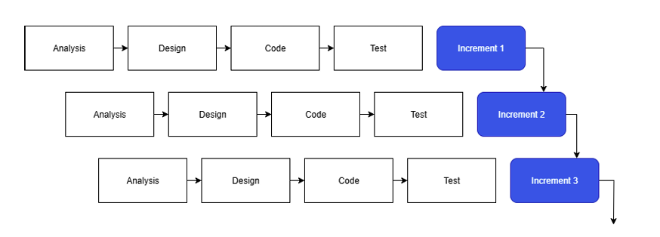
Figure 1.1: Incremental Development

1.6 Report Organization
The report on “Resume-Driven Adaptive Interview Practice System” is structured into six chapters, which include:
Chapter 1: Introduction
This chapter presents an overview of the project. It includes the problem statement, objectives, scope, limitations, and the development methodology adopted for the system.

Chapter 2: Background Study and Literature Review
This chapter covers the fundamental concepts related to resume parsing, Natural Language Processing (NLP), TF-IDF, Cosine Similarity, and adaptive interview systems. It also reviews existing systems and identifies research gaps.

Chapter 3: System Analysis
This chapter describes the requirement analysis and feasibility study (technical, operational, and economical). It also includes system models such as ER Diagram and Data Flow Diagram (DFD).

Chapter 4: System Design
This chapter explains the overall architecture of the proposed system, module design, database schema, and the algorithms used for resume parsing, job recommendation, and adaptive question selection.

Chapter 5: Implementation and Testing
This chapter describes the tools and technologies used for system development, including frontend and backend technologies. It also presents testing methods and results to validate system functionality.

Chapter 6: Conclusion and Future Recommendations
This chapter summarizes the outcomes of the project and provides suggestions for future improvements and possible extensions of the system.

CHAPTER 2: BACKGROUND STUDY AND LITERATURE REVIEW

2.1 Background Study
The advancement of Artificial Intelligence (AI) and Natural Language Processing (NLP) has significantly improved recruitment and interview preparation processes. Traditional interview practice systems rely on static question banks and generic mock interviews, which do not consider a candidate’s specific skills or experience. This creates the need for intelligent systems that provide personalized interview preparation based on individual profiles. Modern AI-driven recruitment platforms and Applicant Tracking Systems (ATS) use resume parsing techniques to extract skills and qualifications from resumes. These systems match candidate profiles with job descriptions using keyword-based and similarity-based methods such as TF-IDF and Cosine Similarity to measure textual similarity.
Several online interview preparation platforms also offer structured mock interviews and automated feedback. However, many provide fixed question sets and lack dynamic difficulty adjustment based on user performance. They often do not offer detailed skill-wise performance evaluation.The growing demand for personalized and data-driven assessment highlights the need to integrate resume analysis, job role recommendation, and adaptive questioning into a unified system. This project combines resume parsing, similarity-based job matching, and rule-based adaptive difficulty adjustment to create an intelligent interview practice platform.

2.2 Literature Review
Ramesh B. E. et al. proposed an AI-Powered Resume Analyzer and Interview Preparation System that utilizes Natural Language Processing (NLP) techniques to extract technical skills and relevant information from resumes. The system automates resume screening and provides role-based interview preparation support. However, it mainly focuses on structured question delivery and does not incorporate dynamic difficulty adjustment based on user performance [1].
Harsh Koshti et al. developed an AI-powered interview preparation platform that analyzes candidate profiles and generates personalized mock interviews with structured feedback. While the system improves skill-based customization, it does not deeply implement similarity-based job role ranking using vector-space models such as TF-IDF and Cosine Similarity [2].
Mayank Chauhan et al. introduced an AI-based resume analyzer and interview simulator integrating resume parsing with automated role mapping and interview simulation. Although the study demonstrates effective resume processing, the adaptive interview mechanism is primarily rule-driven and does not emphasize performance-based difficulty progression [3].
In recruitment automation systems, text similarity techniques such as TF-IDF and Cosine Similarity are widely used for matching resumes with job descriptions. These techniques convert textual data into numerical vectors and compute similarity scores to determine the most relevant role. Additionally, adaptive learning approaches suggest that performance-based question adjustment can improve assessment accuracy and user engagement.

CHAPTER 3: SYSTEM ANALYSIS

3.1 System Analysis

3.1.1 Requirement Analysis

3.1.1.1 Functional Requirement
The functional requirements of the Resume-Driven Adaptive Interview Practice System are as follows:
- Resume Upload: The system must allow users to upload resumes in PDF format for analysis.
- Resume Parsing Module: The system must process the uploaded resume using NLP-based preprocessing techniques to extract relevant information such as technical skills and professional experience from unstructured text. The extracted data will be structured and stored for further job role recommendation and interview generation.
- Job Role Recommendation: The system must recommend the most suitable job role by applying TF-IDF vectorization and Cosine Similarity between extracted skills and predefined job descriptions.
- Adaptive Interview Generation: The system must generate interview questions based on the recommended job role and adjust difficulty according to user performance.
- Performance Evaluation and Feedback: The system must evaluate user responses and generate a structured feedback report highlighting strengths, weaknesses, and skill proficiency levels.
- User Authentication: The system must allow users to register and log in to access personalized features.
- User History: The system must store and display previous interview sessions and performance records.
- Admin Functionalities: The admin must manage users, update the question bank, and monitor system activity.
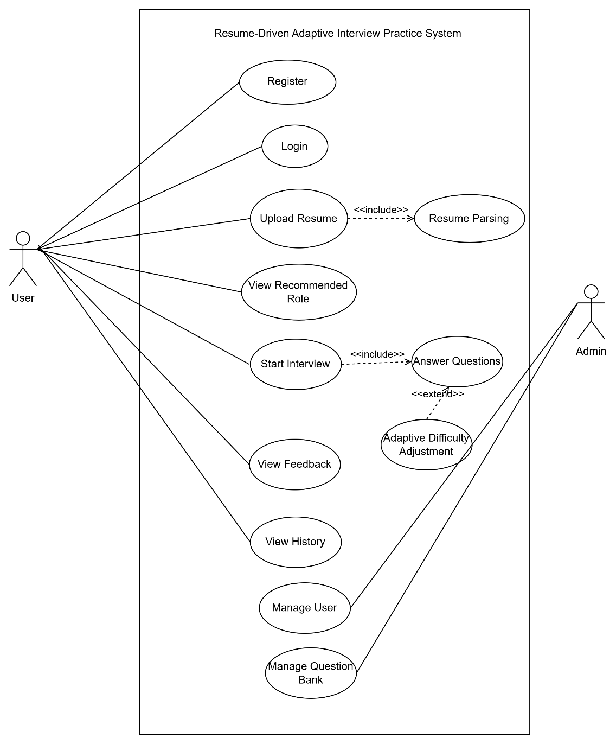
Figure 3.1: Use case diagram

This diagram illustrates how a user interacts with the Resume-Driven Adaptive Interview Practice System. The user can upload a resume, receive a recommended job role, start an interview session, and view feedback and history after completion. Registration and login allow users to store and access their performance records.
Similarly, the admin can log in to manage users and maintain the question bank to ensure smooth system operation.

3.1.1.2 Non-Functional Requirement
The non-functional requirements of the Resume-Driven Adaptive Interview Practice System are as follows:
- Performance: The system must process resumes and generate interview results within an acceptable response time.
- Usability: The system must provide a simple and user-friendly interface for both users and administrators.
- Reliability: The system must operate consistently and handle errors appropriately.
- Security: The system must protect user data through secure authentication and database management.
- Maintainability: The system must be designed to allow easy updates and future enhancements.

3.1.2 Feasibility Analysis

3.1.2.1 Technical Feasibility
The proposed system is technically feasible as it is developed using widely used and well-supported technologies such as Python (Flask), HTML, CSS, JavaScript, and MySQL. The resume parsing module uses NLP-based preprocessing and rule-based techniques for extracting skills and experience. Job role recommendation is implemented using TF-IDF vectorization and Cosine Similarity, which are computationally efficient and suitable for academic-level systems. Since the system does not require heavy deep learning models, it can run effectively on standard computing resources.

3.1.2.2 Operational Feasibility
The system is operationally feasible as it is a web-based application accessible through standard browsers without additional installation. The user interface is designed to be simple and intuitive, allowing users to upload resumes and participate in interview sessions easily. Since the system uses established web technologies, it is easy to deploy, operate, and maintain with minimal operational complexity.

3.1.2.3 Economic Feasibility
The project is economically feasible as it primarily utilizes open-source technologies and tools, minimizing development costs. Since it is an academic project, the main investment is time and effort. The educational benefits, skill development, and practical experience gained from building the system outweigh the associated costs.

3.1.2.4 Schedule Feasibility
The project schedule is feasible within the allocated academic timeline. The system is modular in design, allowing development to be completed phase by phase. Core functionalities such as resume parsing and job recommendation have already been implemented, while remaining components will be completed within the planned timeframe.

3.1.3 Analysis

Data Modeling using ER-diagram.

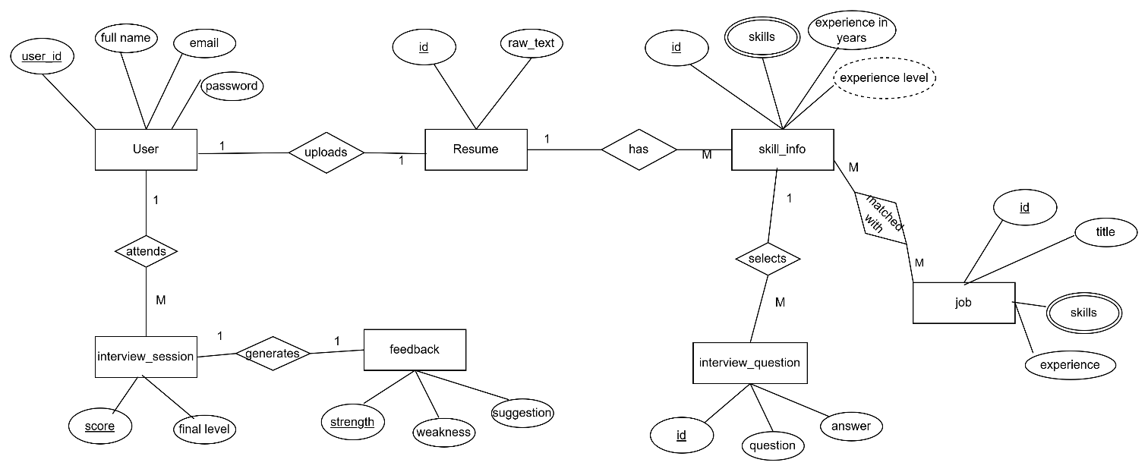
Figure 3. 2 ER-Diagram

Process Modeling using DFD
DFD-0 Level Diagram
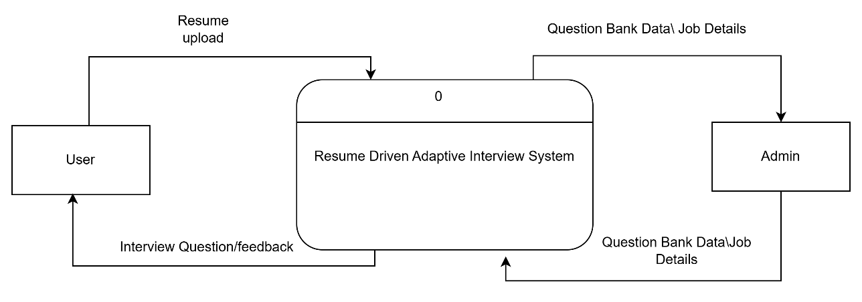

Figure 3.3 DFD-0 Diagram

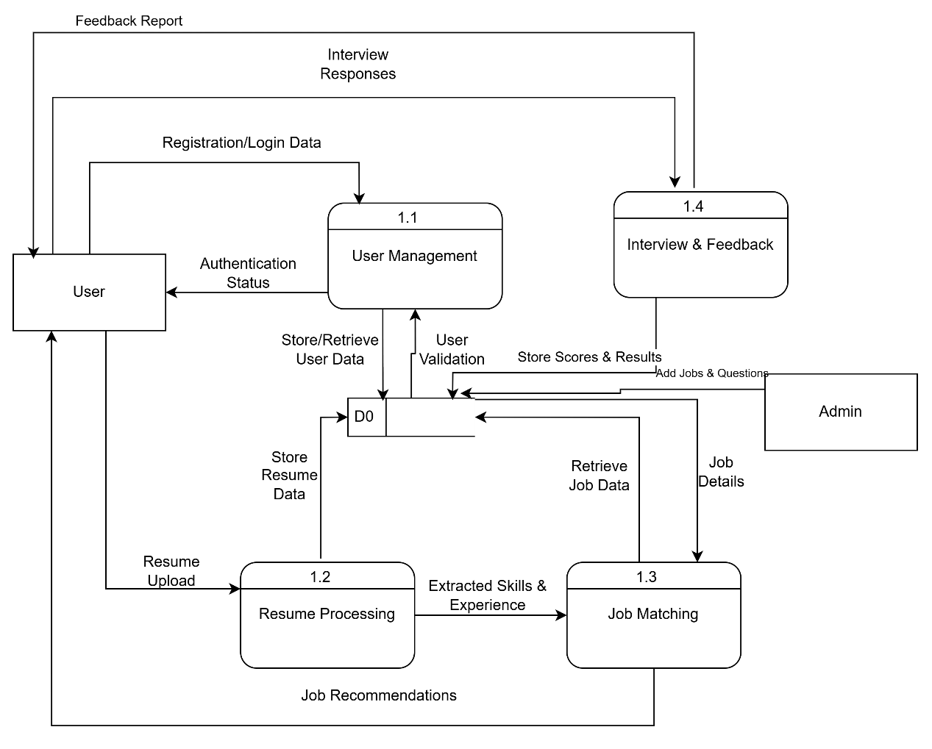

Figure 3. 4 DFD-1 Diagram

CHAPTER 4: SYSTEM DESIGN

4.1 Design

4.1.1 Database Design

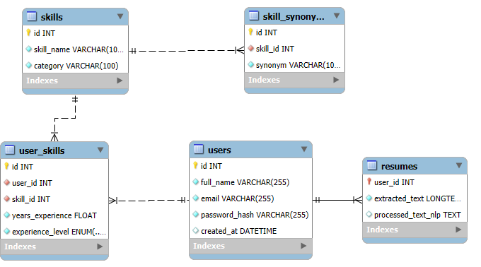

Figure 4.1 Database Design

4.1 Algorithm Details
The Resume-Driven Adaptive Interview Practice System consists of multiple intelligent modules including resume parsing, skill extraction, job matching, adaptive interview question selection, and feedback generation. The major algorithms used in the system are described below.

4.2.1 Resume Processing Algorithm
The Resume Parsing module is responsible for extracting structured information from unstructured resume documents.
Step 1: Resume Text Extraction
- The system reads the uploaded resume in PDF format using pyPDF2
- Extracted content is converted into raw text format.
Step 2: Text Preprocessing
- Convert all text to lowercase.
- Remove unnecessary special characters while preserving meaningful symbols.
- Normalize whitespace.
- Generate a cleaned text version for analysis.
Step 3: Experience Detection
- Identify date patterns (e.g., “June 2019 – July 2021”, “2020 – Present”) using regular expressions.
- Extract start and end year.
- Calculate duration for each job experience block.
- Compute total years of professional experience.
Step 4: Skill Extraction
- Tokenize the cleaned text.
- Compare tokens against predefined technical skill keywords stored in the database.
- Consider synonym mapping for improved matching.
- Identify matched skills and eliminate duplicates.
Step 5: Skill–Experience Mapping
- For each detected experience block, assign its duration to skills appearing within that block.
- If a skill appears without explicit duration, assign total experience.
- Store extracted skills with corresponding experience in the database.

4.2.2 Job Recommendation Algorithm
The job recommendation module identifies the most suitable job role for the candidate.
Step 1: Vector Representation
- Convert extracted user skills into TF-IDF vector representation.
- Convert predefined job skill requirements into TF-IDF vectors.
Step 2: Similarity Calculation
- Compute Cosine Similarity between the candidate vector and each job role vector.
Formula:
Cosine Similarity = $\frac{A.B}{||A|| . ||B||}$
Where:
- A = Candidate skill vector
- B = Job requirement vector
Step 3: Job Selection
- Select the job role with the highest similarity score.
- Validate minimum experience requirement.
- Store recommended job role.

4.2.3 Adaptive Question Selection Algorithm
For each skill:
- Start with an easy question.
- After user answers, calculate PerformanceScore:
  - PerformanceScore = α * Correctness + β * ResponseTime + γ * Confidence
- Decide next question difficulty:
  - NextDifficulty = CurrentDifficulty + f(PerformanceScore)
  - High PerformanceScore → harder question
  - Low PerformanceScore → easier or repeat question
- Continue until all questions are completed or session ends.

4.2.4 Skill Classification and Feedback Algorithm
For each skill:
- Calculate percentage of correct answers.
- Assign proficiency:
  - ≥80% → Strong
  - 50–79% → Medium
  - <50% → Weak
- Display results using visual charts or tables.

CHAPTER 5: IMPLEMENTATION AND TESTING

5.1 Implementation

5.1.1. Tools Used
The following tools and technologies were used during the development of the system:
- Programming Language
- Python – Used for backend development, resume processing, algorithm implementation, and system logic.

- Web Framework
- Flask – A lightweight Python web framework used to build the backend application and handle routing, authentication, and request processing.

- Frontend Technologies
- HTML – For structuring web pages.
- CSS – For styling and layout design.
- JavaScript – For client-side interaction and dynamic behavior.

- Database
- MySQL – Used for storing user data, resume information, job details, interview sessions, and feedback records.

5.1.2. Implementation Details of Modules
The Resume-Driven Adaptive Interview Practice System is divided into several functional modules which are as follows:

Module 1: User Management Module
It handles user registration, authentication, and session management. It allows users to create accounts, log in securely, and access personalized features. User credentials and profile information are stored in the database, ensuring secure and controlled access to the system.
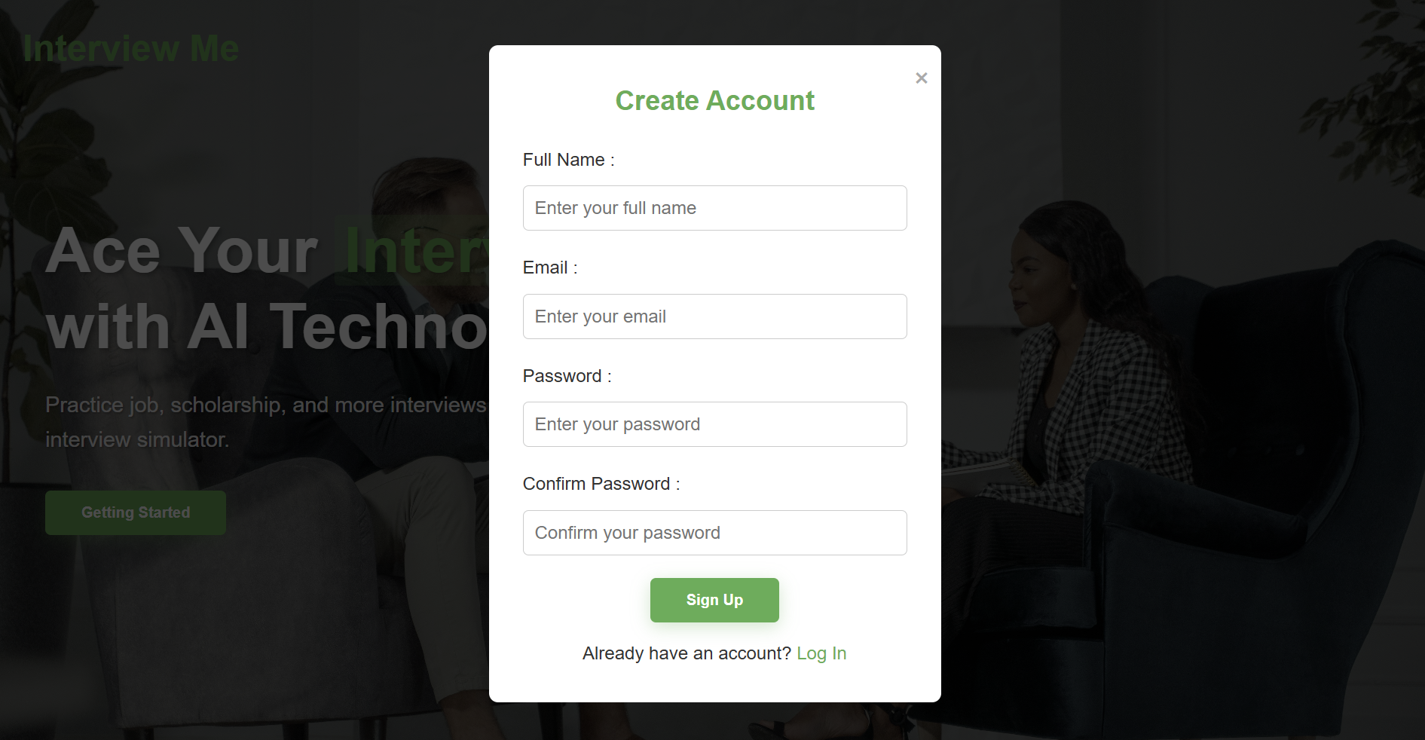

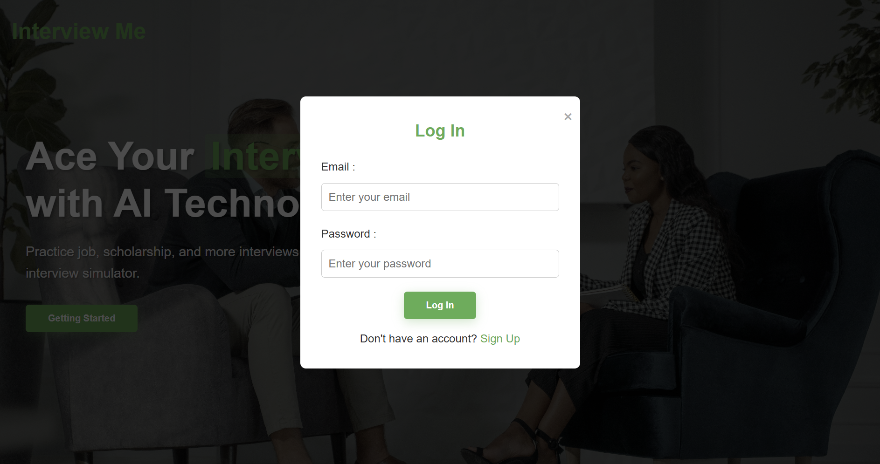

Module 2: Resume Processing Module
This module is responsible for analyzing uploaded resumes and extracting structured information.
It includes the following sub-components:
- PDF Reader: Uses PyPDF2 to extract raw text from uploaded PDF resumes.
- Text Preprocessing: Performs structural cleaning and NLP cleaning.
- Experience Extraction: Detects experience duration using regular expressions and calculates total years.
- Skill Extraction: Identifies technical skills using rule-based matching.
- Experience Classification: Classifies users as Beginner, Intermediate, or Advanced based on total experience.
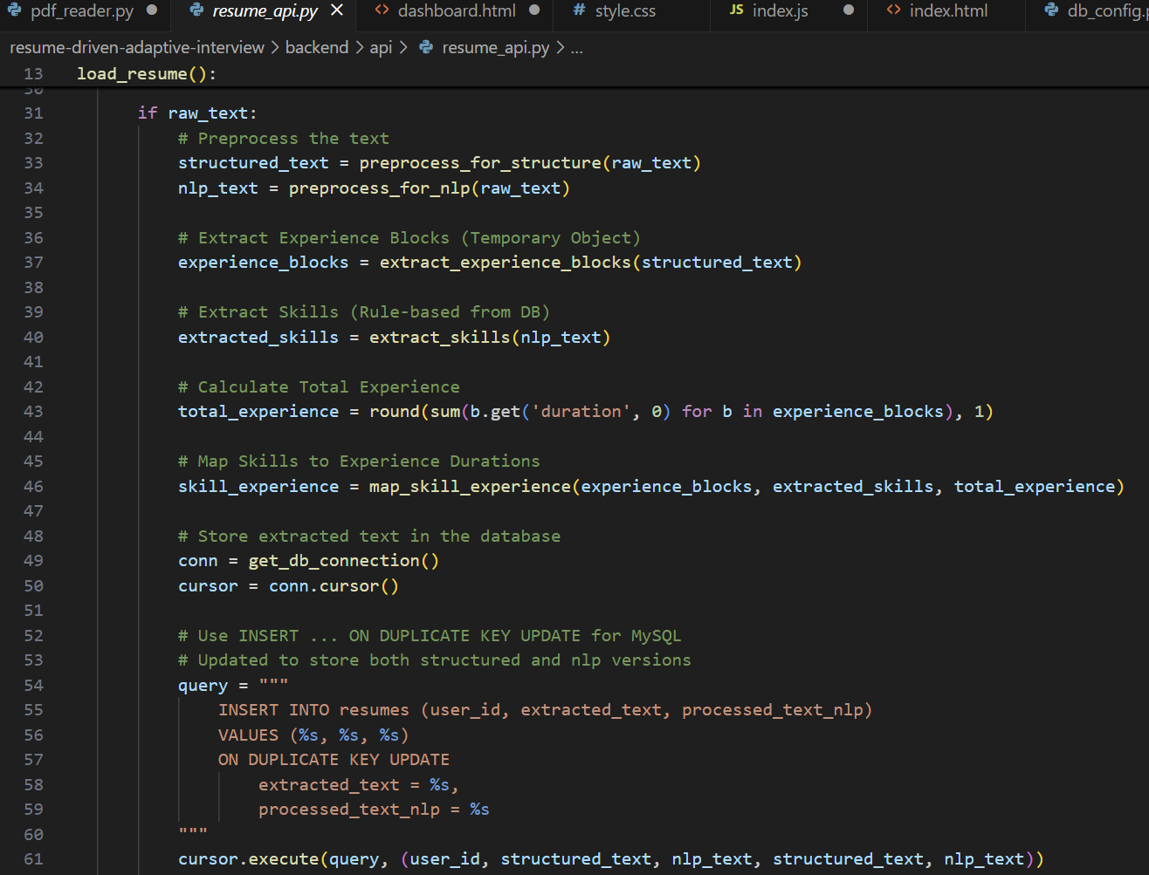
The output of this module is structured skill and experience data used for job matching.
Module 3: Job Matching Module
It recommends suitable job roles based on extracted skills and experience. It converts resume data and job descriptions into numerical vectors using TF-IDF and calculates similarity scores using Cosine Similarity. Jobs are ranked according to similarity values, and the most relevant roles are suggested to the user.

Module 4: Adaptive Interview Module
It conducts a dynamic interview session tailored to the candidate’s skills and experience level. It selects questions based on skill relevance and adjusts difficulty according to performance using a scoring mechanism. This ensures personalized and progressive evaluation.

Module 5: Feedback and Evaluation Module
It analyzes interview performance by calculating skill-wise accuracy and classifying proficiency levels. Based on the results, it generates strengths, weaknesses, and improvement suggestions, providing a structured performance report to the user.

5.1 Testing

5.1.1Test Cases for Unit Testing

Table 5. 1 Test case For Registration

ID | Test Case Description | Test Data | Expected result | Actual Result | Test  Result
R_1 | User enters valid signup information | Enter full name: Ram Sharma  Enter your email: ram@gmail.com  Create password: 123456  Confirm password: 123456 | Redirects to Login Page | Redirected to Login page | Pass
R_2 | User enters different password and confirm password | Enter full name: Ram Sharma  Enter Your email: ram@gmail.com Create password: 123456  Confirm password: 23459 | Display Error Message. | “Password and Confirm password didn’t match.” | Pass

Table 5. 2 Test Case for User Signup

ID | Test Case Description | Test Data | Expected result | Actual Result | Test  Result
L_1 | User enters valid login information | Enter your email: ram@gmail.com Enter your password: 123456 | Redirects to User Dashboard  page | Redirects to User Dashboard  page | Pass

L_2 | User enters invalid login information | Enter your email: asas@gmail.com  Enter your password: 098765 | Display Error Message | “Please enter a correct username and password.” | Pass
L_3 | User leaves the login  fields empty. | Enter your email: ram@gmail.com Enter your password: | Display Error Message | “Please enter password." | Pass

Table 5. 3 Resume Upload Test Cases

ID | Test Case Description | Test Data | Expected Result | Actual Result | Test Result
RU_1 | Upload valid PDF resume | resume.pdf | Resume uploaded & text extracted | Successful upload | Pass
RU_2 | Upload non-PDF file | resume.docx | Error: Only PDF allowed | Error displayed | Pass
RU_3 | Upload empty file | empty.pdf | Error message | Error displayed | Pass

Table 5. 3 Text Preprocessing Test Cases

ID | Test Case Description | Test Data | Expected Result | Actual Result | Test Result
TP_1 | Remove special characters | Python!!! Flask@@ | python flask | python flask | Pass
TP_2 | Convert to lowercase | Machine Learning | machine learning | machine learning | Pass
TP_3 | Remove extra spaces | python sql | python sql | python sql | Pass

table 5.3 Skill Extraction Test Cases
ID | Test Case Description | Test Data | Expected Result | Actual Result | Test Result
SE_1 | Extract known skills | python, sql, flask | Skills stored in DB | Stored correctly | Pass
SE_2 | No predefined skills | random text | No skills extracted | None stored | Pass
SE_3 | Duplicate skill mention | python python | Stored once | Stored once | Pass

5.3 Result Analysis

CHAPTER 6: CONCLUSION AND FUTURE RECOMMENDATION

6.1 Conclusion

6.2 Future Recommendation

References

[1] | R. B. E, P. K. R, P. . K. B. Patil and A. K. V, "AI-Powered Resume Analyzer and Interview Preparation System," International Journal for Research in Applied Science and Engineering Technology, vol. 13, no. 11, pp. 2558-2567, 2025.
[2] | H. Koshti, P. Gosavi, . R. Pagar, P. Khairnar and S. Talekar, "AI-Powered Interview Preparation System: Integrating Resume Analysis, HR Simulation, and Technical Skill Assessment," Journal of Engineering Research and Reports, vol. 27, no. 5, pp. 21-33, 2025.
[3] | M. Chauhan, M. M, R. M. J, P. P, N. S and R. L, "AI-Based Resume Analyzer and Interview Simulator," HBRP Publication, vol. III, no. 2, pp. 8-18, 2025.

